**Project 3: Car Keys**

By Aaron Sotzen (PID #A17183424), Fiona Liu (PID #A16880107), Karina Chen (PID #A16322803), Sunay Bargotra (PID #A17221160), Valen Potloff (PID #A16225246)

DSGN 1 Winter 2022

9 AM Section

**Section I: Data Collection**

**Part A: Brainstorming**

When we were brainstorming ideas for what design to do in this project, we first made a **mind map** of a bunch of different designs that we had encountered difficulties with in the past (Figure 1). These included both digital and physical designs. At first, we wanted to do some features of a digital app, like inserting an image in Google Docs or the share screen function in Zoom. However, we also had many physical objects that we wanted to analyze further, like USB chargers and car keys.

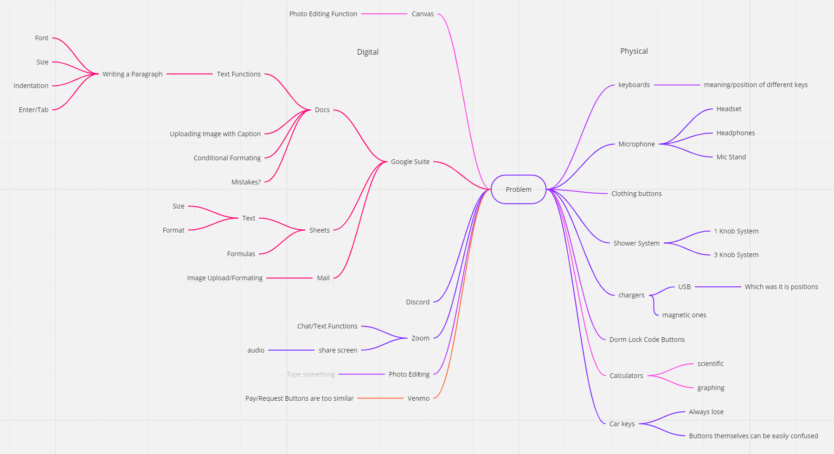

Figure 1: Mind map of different digital and physical designs: <https://miro.com/app/board/uXjVOQEpqwM=/?invite_link_id=301440344901>

Car keys was a suggestion on the **mind map** that came about after one of our members got locked out of her room because she forgot her university card key. We wanted something with a little more different avenues to explore with different designs and potential errors, so we ended up adding car keys instead of a card key. After doing this mind map, we decided that car keys were also very widely used in the general population, so it was easy to get a variety of interview responses from different people. We then created another mind map just for car keys to get more detail on the design and common errors that are made when using them (Figure 2).

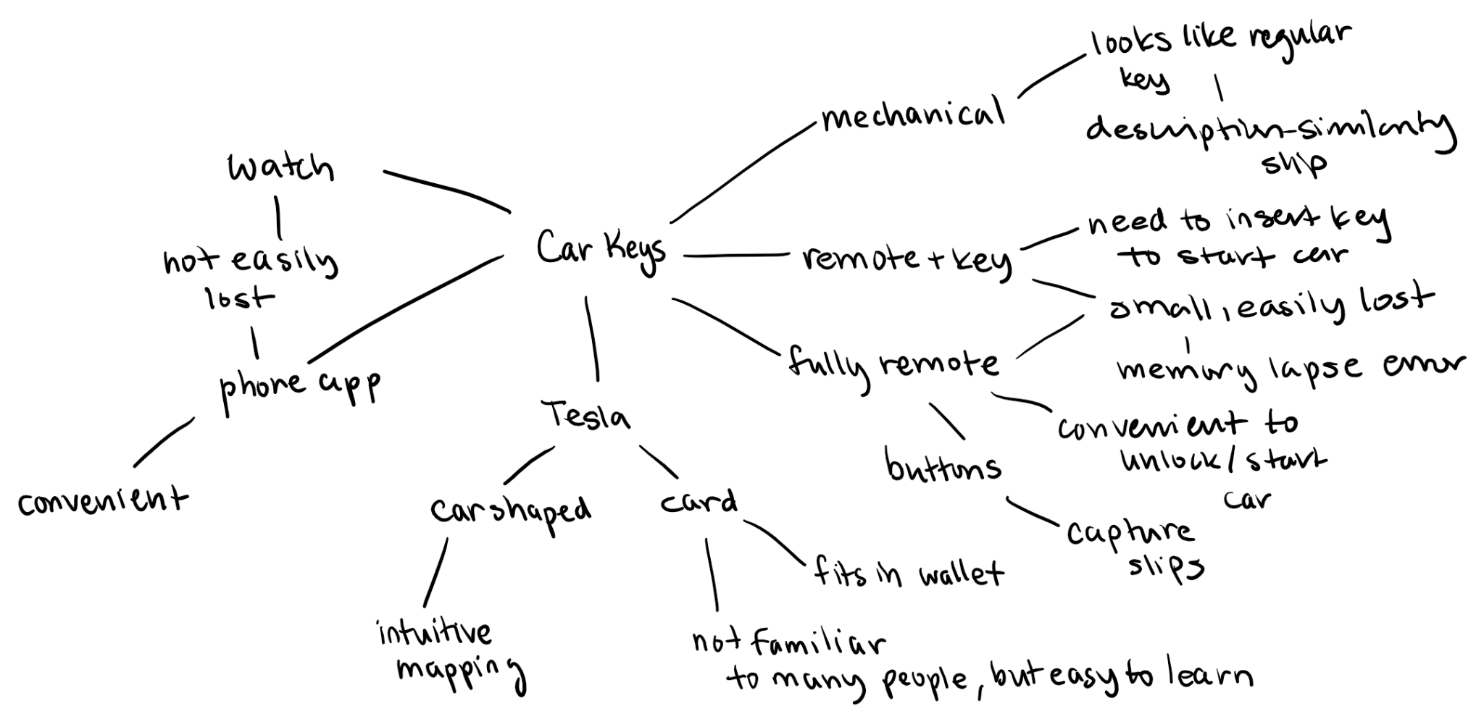

Figure 2: Car key mind map

**Part B: Interview Methodology**

We came up with a list of interview questions on a shared document, with the majority of the questions being brainstormed during the extra time we had to work together in class. Then, we added some general questions to get the demographic information of each interviewee and some rating questions at the end to get some more quantitative data.

Our interviewees include our friends, family members, and other acquaintances. We only chose people to interview who already know how to drive and have their license, so they would have sufficient experience with the topic of car keys. Most of our interviewees are college students on a college campus, so the data could be slightly biased because of the frequency of driving. However, driving is not split by generation, so this should not have a big impact on our results.

The majority of our interviews were conducted with answers inputted into a Google form so we could get the data quickly aggregated in a spreadsheet. However, we also had a few interviews conducted face-to-face, where we were able to watch them perform tasks and ask follow-up questions to get more detailed answers.

We utilized the **master-apprentice model** while crafting our interview questions. A lot of the questions would be considered common knowledge, but in our roles as “apprentices” with our interviewees as the “masters”, we wanted to make sure we got as much information as we could using this method. Therefore, we asked questions that aimed to get both quantitative and qualitative data, with both open-ended questions and more specific, straightforward questions. All of the questions were supposed to be fairly easy to answer, but gave us a lot of insight into each user’s opinions and thought process while using their car keys.

**Interview Questions**

Pre-Task Questions

General Questions: Gauges interviewee population and their everyday relationship to driving (essentially gets demographic data)

1. What age range are you?
   1. 16 –18 years old (teenager, typical high school age)
   2. 18 – 22 years old (young adult, average undergrad age)
   3. 23 – 30 years old
   4. 30+ years old
   5. We chose to ask this question mainly to get the age demographics of our interviewees. While looking at the data, we can see if there is a distinction between habits or opinions of different age groups.
2. What type of community do you live in (rural, suburban, urban, college campus, etc.)?
   1. We chose to ask this question, like the previous one, to get the demographic information of our interviewees. While looking at the data, we can see if there is a distinction between habits or opinions of different groups of people depending on where they live.
3. On an everyday basis, do you tend to drive or use public transportation or a mix of both?
   1. We chose to ask this question to see how often our interviewees drive, and therefore interact with their car keys. It is likely that those who drive more will have more experiences with losing their car keys or be more skilled in using different types of car keys (having a more complete **mental model**), while those who drive less might not have encountered some errors while using their car keys because they don’t drive as much. Having more experience driving and using their car keys can impact how they perform or describe certain relevant tasks. It was important to us that we got interviewees who are always driving, and some that only drive once in a while, so we could see the range of potential errors.
4. If you drive, what are some of the places/occasions you drive to?
   1. This question looks at urgency and how **errors** can impose delays. Some people might drive to work or school, and the need to be on time could cause more errors. It is also to get an idea of how far people are driving on average to again gauge how familiar they are with driving.

Driving Specific Questions:

1. How often do you drive?
   1. This question identifies how familiar a person might be with their car keys and the likelihood of them having had bad experiences with their car keys due to their driving more often.
2. How many cars do you have?
   1. The purpose of this question is to see how many different types of car keys a person might have been exposed to.
3. What kinds of cars do you own/drive?
   1. The purpose of this question is also to see how many different types of car keys a person might have been exposed to.
4. What kind of key does your car have (mechanical, remote, etc.)? If you have multiple cars, describe both keys.
   1. The purpose of this question is also to see what different types of car keys a person has used before, and which types of car keys are more common. This also allows us to categorize each type of car key and analyze whether one kind of car key has a better design than another.
5. How long did it take you to learn how to use your car key(s)?
   1. This question aims to get the size of the **gulf of evaluation** and the **gulf of execution** – how long it took someone to figure out how to use their car keys and then actually perform that action to get their desired result, for example, locking or unlocking their car or starting their car. It also speaks to the **signifiers**, **affordances**, and **feedback** of the keys to help them bridge these gulfs.
6. Can you describe the functionalities of your keys? (buttons, etc.)
   1. The purpose of this question is to get at the **affordances** of the car keys and the user’s understanding of each **affordance**. It also allows the user to discuss their **mental model** of how their keys work.
7. Do you know where your car keys are right now? Where?
   1. This question aims to identify whether **memory lapse mistakes** are common errors that are made with car keys, since it seems like people often are forgetting where they put their keys or losing their keys.
8. On average, how often does it take you to find your keys when you leave the house/go out?
   1. This question is similar to the previous question, as it gets more detail about a user’s actions to get their keys and a quantitative value to measure the severity of a potential **memory lapse mistake**.
9. Have you ever lost your keys? If so, how often does this happen? What was that experience like?
   1. This question carries a slightly different meaning than the previous question. It targets lost keys rather than misplaced ones. However, the purpose of this question is also to identify **memory lapse mistakes**. Asking about their experience gets into their state of mind and what condition they were in when they lost their keys, and allows us to think about how the design could mitigate these errors when the user is in a hurried state.
10. How do you carry your key when you’re out of the house? (on a keychain/lanyard, in your pocket/purse, by itself, etc.)
    1. This question is supposed to identify how a user carries their keys around to minimize any **memory lapse mistakes** in losing or misplacing their keys. It is potentially a way the car key design could be improved so it is easy to store or carry when a user is not using it.
11. Do you store your keys in a certain area or place at home? If so, where?
    1. This question is similar to the previous question, but for when the user is at home. It still identifies whether users are doing anything with the key to prevent or minimize **memory lapse mistakes**.

Task Questions:

1. What is the process of locking/unlocking your car?
   1. The purpose of this question is to see how a user interacts with their car key and to describe/visualize the process of a very common task they need to do when driving. In hearing or seeing their process, we can identify common **errors** that users make while performing this task or what they find inconvenient, and improve the design accordingly.
   2. Rate the difficulty level of this task (1 easy - 5 difficult)
      1. Rating the difficulty level gets a quantitative data point for the process.
   3. In-Person Interviews: Asked the interviewee to demonstrate the process, and noted down anything that stood out, for example, any **signifiers**, **feedback**, and **errors**.
2. What is the process of starting your car? (insertion, start button, etc.)
   1. This question is similar to the previous task, as it also asks the user to demonstrate or describe a common process. Since different car keys are utilized in different ways to start a car, it is important to note which method is faster and less error-prone for most users.
   2. Rate the difficulty level of this task (1 easy - 5 difficult)
      1. Rating the difficulty level gets a quantitative data point for the process.
   3. In-Person Interviews: Asked the interviewee to demonstrate the process, and noted down anything that stood out, for example, any **signifiers**, **feedback**, and **errors**.

Post-Task Questions:

1. Have you ever forgotten to lock your car? If so, how often?
   1. This question aims to get at any **memory lapse slips** a user might make. Since there is nothing in a car key that reminds a user to lock their car, it is an error that is likely fairly common.
2. What parts of your car key do you like? What parts can be improved?
   1. This question gets the user’s opinions on their car key – it pinpoints what the user deems important or what could be improved in their glasses – essentially what stands out to them. The interviewee could talk about the **affordances**, potential **slips** and **mistakes**, **trade offs**, **constraints**, or anything else they have an opinion on.
   2. If you have multiple cars, is there a car key that you prefer over the other and why?
      1. This question identifies the users’ preference for a certain car key over another, which could be largely in part due to the design of the key. This informs us what design is more effective for a car key.

Rating Questions: Show a few different car keys and ask to rate from (1 easy - 5 difficult)

* Difficulty level to figure out
* Difficulty level to use
* Difficulty level to store

The purpose of asking the user to rate different car keys is to identify what characteristics make a well designed car key and what designs users might have difficulty with or make more errors using.

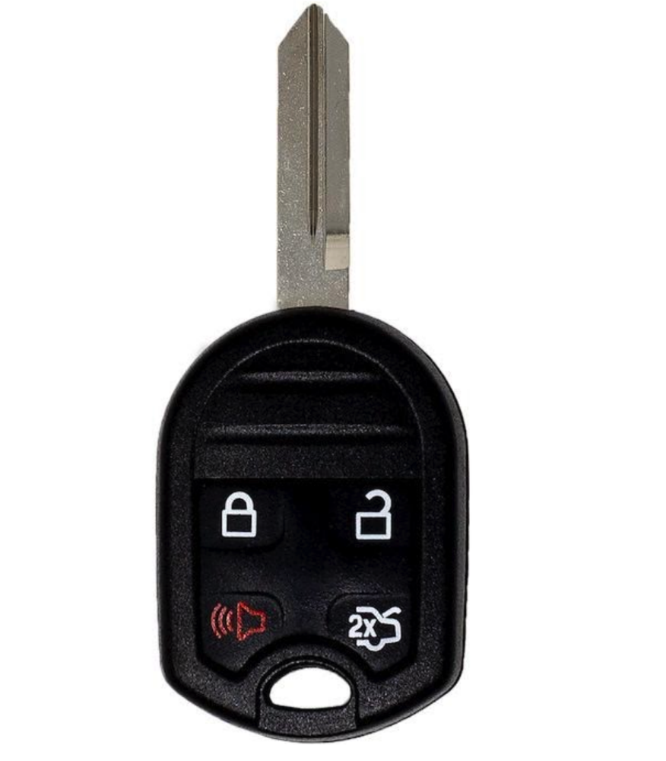

1. Car Key 1
   1. This car key is pretty standard with four buttons and a single mechanical key. The buttons have three buttons that we would consider **cultural constraints**, as they have conventional meanings: i) the lock symbol **signifier**, the unlock symbol **signifier**, and the sound symbol **signifier**.

Figure 3: Car Key 1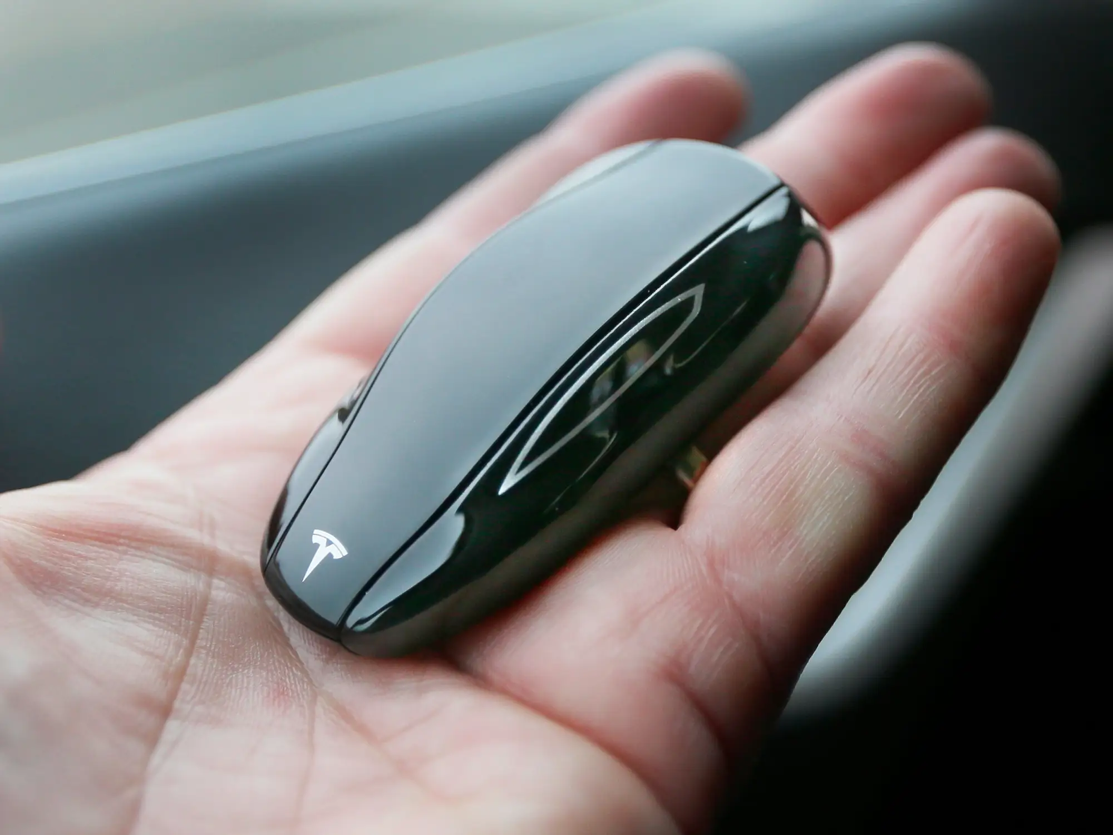

1. Car Key 2
   1. This car key was intended to be confusing on the survey. It seems to lack proper **signifiers**, which can lead to **knowledge-based mistakes** for first-time users.

Figure 4: Car Key 2

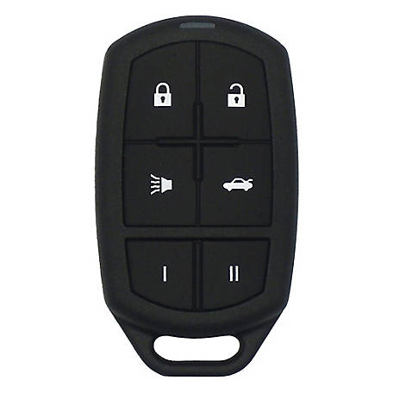

1. Car Key 3
   1. This car key is similar to Car Key 1, with the exception of some additional buttons and the omission of the mechanical key that juts out, which could provide better storage capabilities.

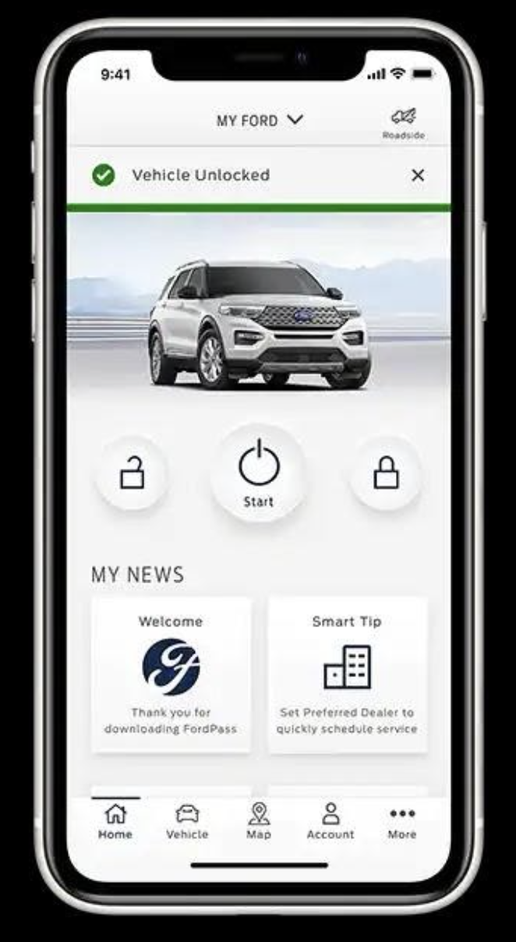

Figure 5: Car Key 3

1. Car Key 4
   1. This was a more modern take on a car lock system; its form as an app makes it extremely portable for the smart-phone-carrying population, allowing easy storage, but its complexity could be difficult to figure out and dependent on the battery of one’s phone, highlighting a potential **tradeoff.**

Figure 6: Car Key 4

1. Car Key 5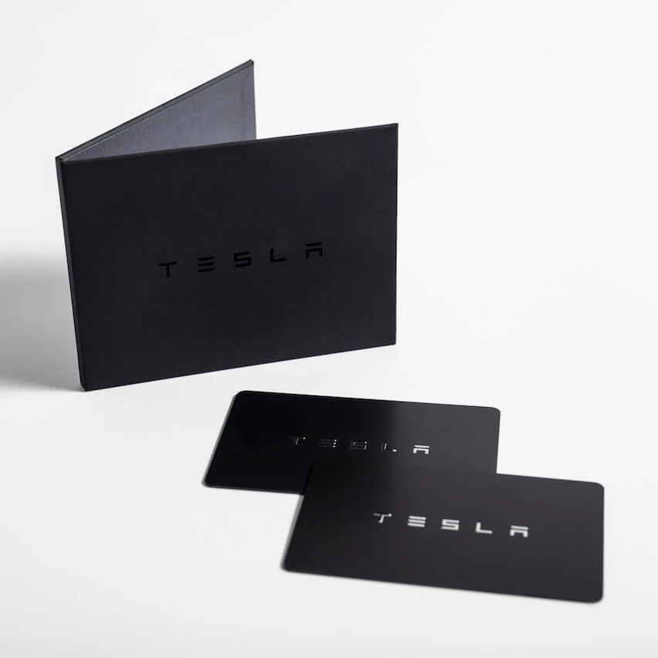
   1. This is also a very innovative car lock system, and its card form makes it quite easy for users to store in their wallets (which, interestingly enough, is contrary to the common situation of college students misplacing their key cards). However, its compactness and sleekness may interfere with its accessibility within the **gulfs of execution and evaluation**, posing a similar **tradeoff** to Car Key 4.

Figure 7: Car Key 5

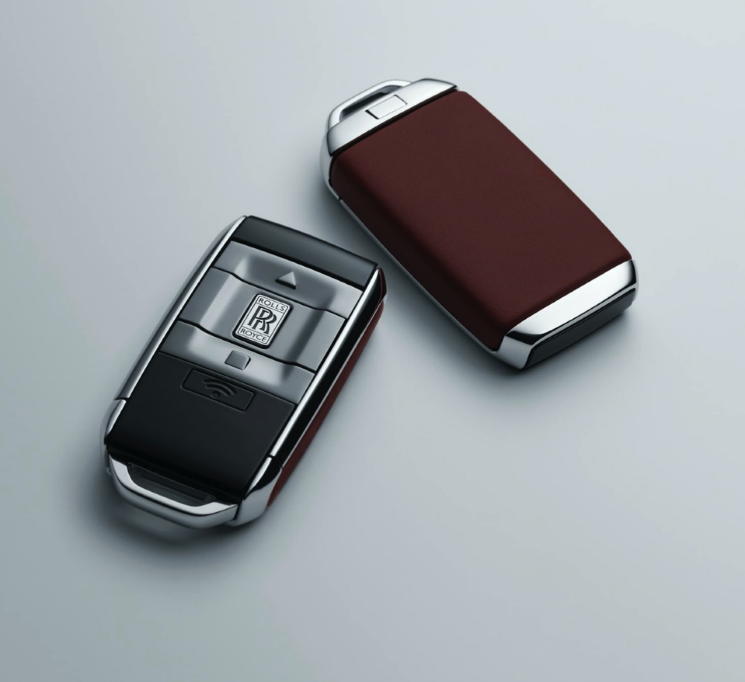

1. Car Key 6
   1. Though this car key employs a traditional system of having buttons on a physical key, the **signifiers** on the buttons deviate from **cultural constancy**, which cause **knowledge in the head** mistakes for first-time users.

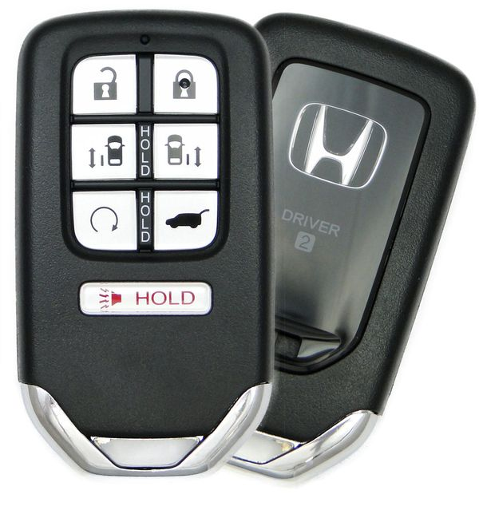

Figure 8: Car Key 6

1. Car Key 7
   1. This car key is similar to Car Keys 1 and 3, but we wanted to see if the similarity in buttons would provoke users to make potential **description-similarity slips**.

Figure 9: Car Key 7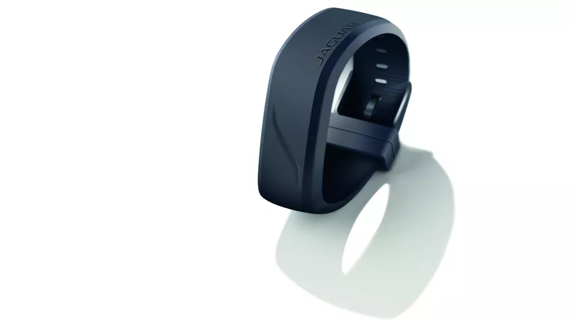

1. Car Key 8
   1. This car key emphasizes portability by having it be physically more attached to the user, but like many of the other car keys that prioritized portability, it poses **tradeoffs** of ease in the **gulfs of execution and evaluation**.

Figure 10: Car Key 8

**Part C: Proof of Data**

We collected our data through surveys and in-person interviews, so we have one spreadsheet generated by the Google Form and on another sheet within the same document, we have the data collected during the in-person interviews.

Figure 11: The Google Form we disseminated ([link](https://forms.gle/Cmh2q2JCDD7kCX529))

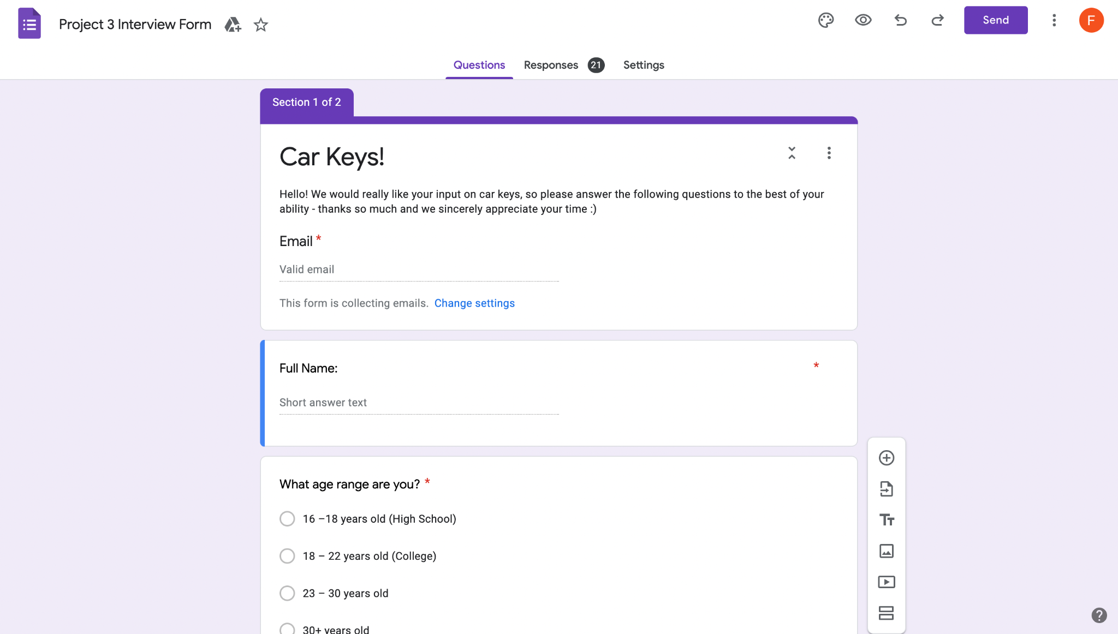

Figures 12, 13 & 14: Survey Sheet from the Google Form and In-Person Interview Data ([link](https://docs.google.com/spreadsheets/d/1wmcAiJGH2S-FSh47SHDtOPEukTUVD6peaRkHfYadD94/edit?usp=sharing))

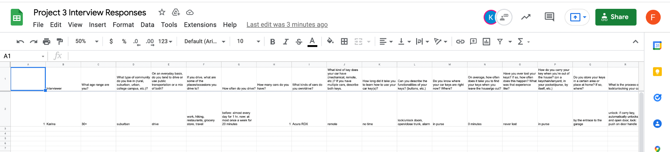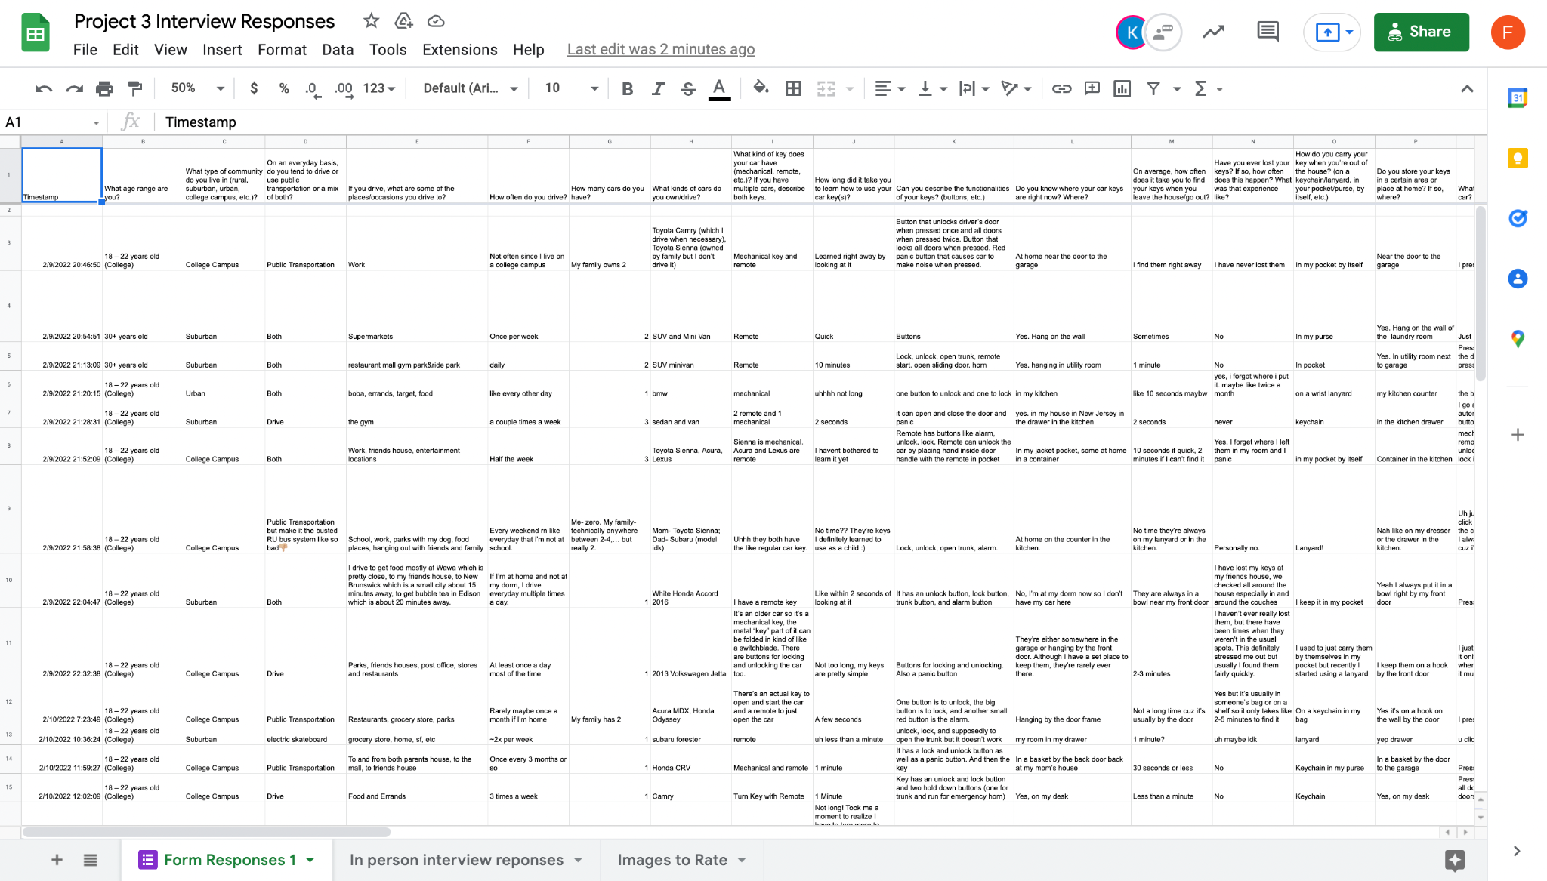

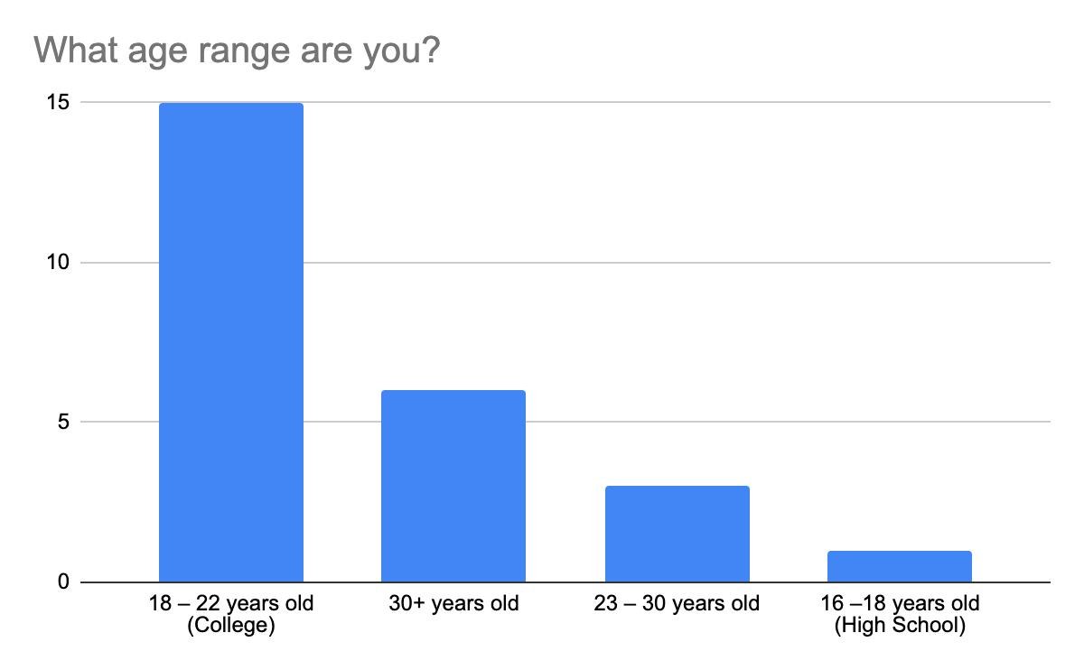

Figure 15: Distribution of the age range of our respondents. Most interviewees are of college age.

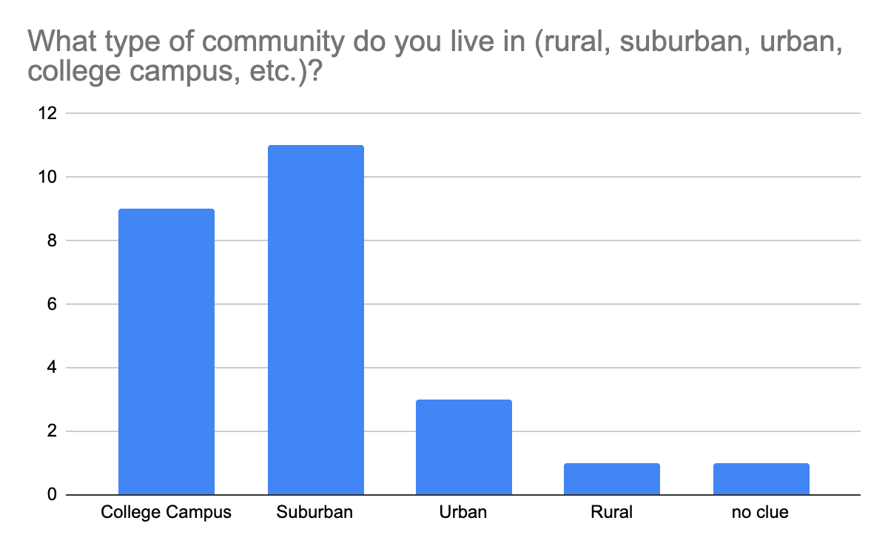

Figure 16: Distribution of the types of communities our respondents live in. Most live on a college campus or in a suburban area.

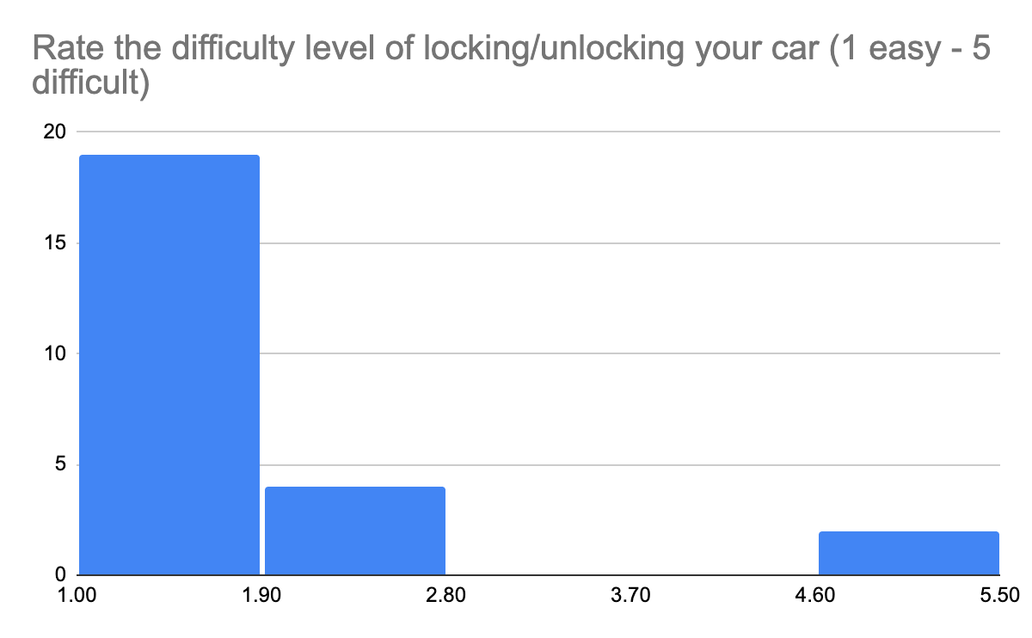

Figure 17: Distribution of our respondents difficulty with locking/unlocking their car. Most users found it very easy to unlock/lock their car, with some finding it very difficult to.

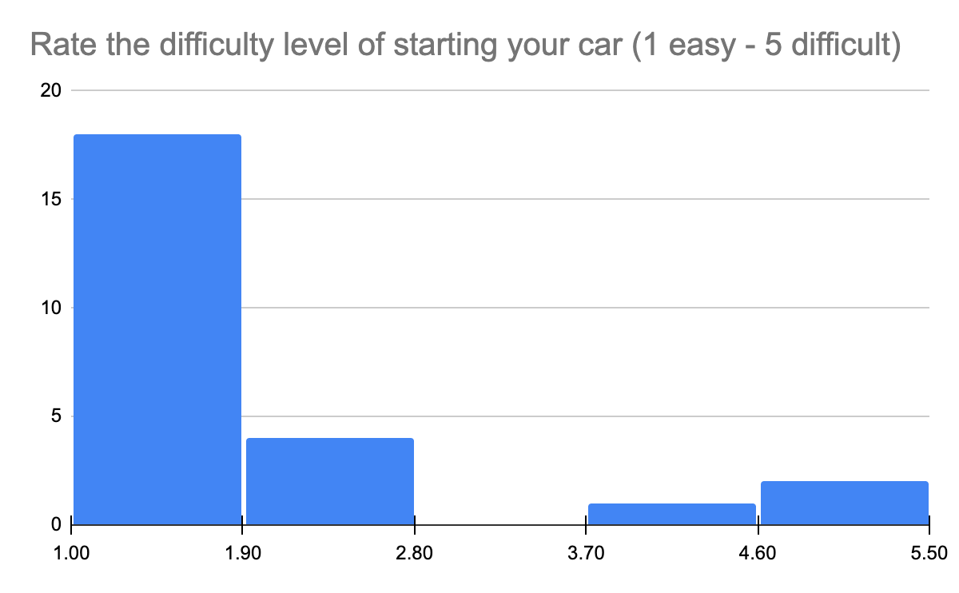

Figure 18: Distribution of our respondents difficulty of starting their car. Most find it very easy to start their car while a few find it difficult.

**Part D: Contributions**

Valen: 3 of 27 total responses (all Google Form); Primarily took care of tradeoffs, made graphs, and made edits throughout

Katrina: 6 of 27 total responses (5 Google Form, 1 interview); Primarily took care of methodology, interview questions, identifying errors, and made edits throughout

Fiona: 10 of 27 total responses (all Google Form); Primarily took care of interview questions, identifying errors, and made edits throughout

Sunay: 3 of 27 total responses (2 Google Form, 1 interview); Primarily took care of redesign (including depiction), creating graphs for the design space, and made edits throughout the document

Aaron: 5 of 27 total responses (all Google Form); Primarily took care of design space, redesign and made edits throughout the documents

**Section II: Error Analysis**

**Identify & Classify Errors**

When we were conducting the in-person interviews, we paid attention to the errors that were made, in addition to the form questions asking if they had made any errors like losing or misplacing their keys or forgetting to lock their car. 12 out of the 27 total interviewees said that they had lost or misplaced their keys at least once and 15 out of the 27 have forgotten to lock their car before. Unfortunately, we were only able to get 2 in-person interviews to observe the users actually performing the tasks, so there is not much data to generalize these errors, and these users did not make any noticeable errors either. Among all the interviews, **memory lapse errors** were the most common, but this could also be because it was the type of error we asked most about in the interview.

There were two main frames of errors we had hypothesized about:

**Misplacing keys**

One of the most common issues we were expecting were **memory lapse errors**. Coincidentally enough, on the due date of this project, this was in Apple News:

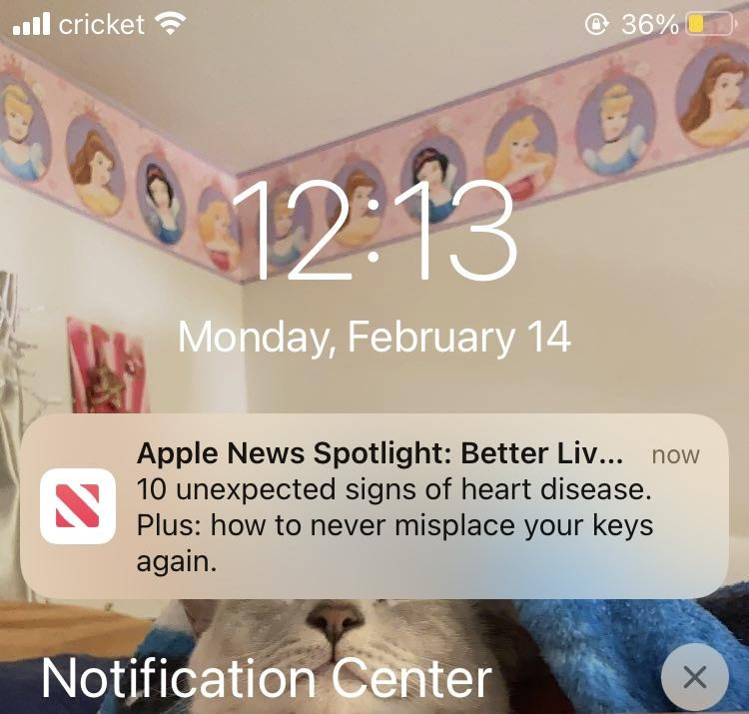

Figure 19: Apple News Headline on February 14, 2022

When asked if they’ve ever lost their keys, 12 out of 27 total interviewees admitted to either losing or misplacing their keys at least once before. These responses recounted the experiences to be “upsetting” and “stressful,” and one response detailed the situation:

“I lose my keys around twice a month. There was one time where I was extremely tired after a long day and forgot to use the key hook. The next morning I was in a rush so I wasn't late for class and panicking because the keys weren't on the hook. I later found them under the table as they and [sic] fallen off after I put them on the table.”

There are multiple errors that could arguably be embedded in this issue. The most prominent is a **memory lapse slip**. Don Norman writes in *The Design of Everyday Things* that memory lapse slips can both lead to and result from “forgetting the outcome of an action” (Norman 176). The goal of finding the key would be correct, but failure to remember where the key was last seen would be classified as a **slip**; similarly, while putting down the key after use is the correct mental model, failure to remember where you put it down would also be classified as a **slip** - in both situations, you never intended to have an incorrect goal of losing your keys, but failure in memory resulted in this **error**.

However, this could arguably be a **memory lapse mistake** as well. Norman states that “a common cause of the lapse is an interruption that leads to forgetting the evaluation of the current state of the environment…forgetting earlier evaluations often means remaking the decision, sometimes erroneously” (Norman 185). In a situation where you normally place your keys in one spot, but happened to misplace them one day, the next time you look for your keys, your outdated **mental model** is that they should be in their usual spot, but they’re not; when you go to look in the usual spot, you’ve make the **mistaken** decision to look in a place where your keys are not.

We would characterize this to be more of a **human error**, as a large portion of it is about individual organization skills, but for both of these cases, it’s worth mentioning that users have already attempted to combat this issue; every single respondent stated that they had a designated place for their keys in their home, citing usages of “hooks,” “bowls,” “drawers,” etc. Because of this, a case can be made that there is a fault in the **design** **function** for the consistent **knowledge in the head** that is necessary to keep track of where car keys are.

**Function confusion**

Due to the small size of car keys, we anticipated that many users would accidentally press the wrong button; for example, pressing the unlock button while trying to lock their car. In this case, the user would have had the correct mental model, and just executed the wrong action. This could be considered either a **capture slip** or a **description-similarity slip**. Don Norman defines a **capture slip** as “the situation where, instead of the desired activity, a more frequently or recently performed one gets done instead: it captures the activity” (Norman, 174). This is possible if, for example, the user had just recently pressed the unlock button, and after arriving at their destination, accidentally pressed the unlock button instead of the lock button to lock their car. A **description-similarity slip**, on the other hand, is when one “act[s] upon an item similar to the target”, and “this happens when the description of the target is sufficiently vague” (Norman, 175). For the buttons on a car key, they are all in close proximity and all feel and/or look similar (Figure 16). This makes it easy to accidentally press the wrong button.

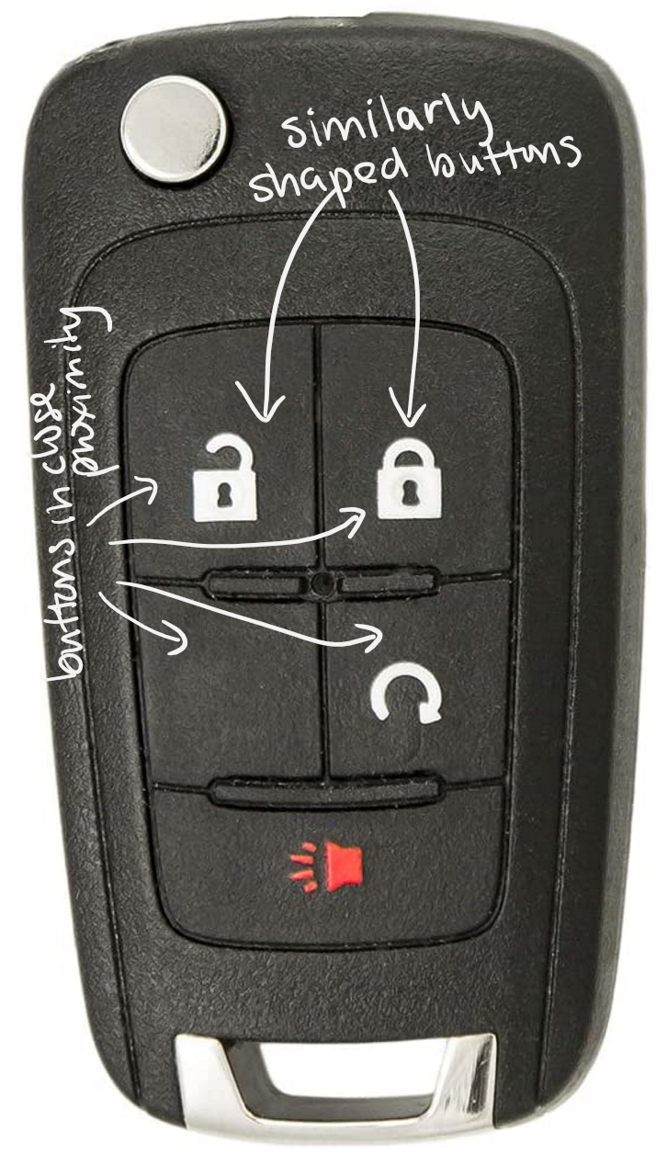

Figure 20: Car key with similarly placed and labeled buttons

However, this error was not really addressed in our interview questions, and we did not notice any issues with this during our two in person interviews, consequently disproving our hypothesis. To lock or unlock their cars, 22 of the 27 users need to press the buttons on their car keys, so if it is a common error with messing up the different buttons, many of the users would likely have made this error before. This is something that we could interview people on in more depth in the future, but for now, it is arguably easier to just get rid of the possibility of this error at all by minimizing the amount of times a user has to press the buttons.

In fact, when reviewing the ratings for ease of use, the two lowest ratings (easiest to use), were Car Key 1 (average 1.48/5) (Figure 17) and Car Key 3 (average ~1.71/5) (Figure 18), both of which had the simple traditional lock and unlock **signifiers**. These two car keys also fell in the lowest ratings for easiest to figure out at an average of 1.88/5 and 2.2/5, respectively.



Figure 21: Car Key 1 Figure 22: Car Key 3

The two rated more difficult to use were Car Key 2 (average 3.04/5) (Figure 23) and Car Keys 5 (Figure 24) and 6 (Figure 25) (tied at an average of 2.52/5). They also had the three highest ratings for difficult to figure out at an average of 3.92/5, 3.36/5, and 3.92/5, respectively. In all of these, they either lack clear **signifiers** or lack **signifiers with cultural constancy**; this can result in **knowledge-based mistakes** from a lack of understanding.





Figure 23: Car Key 2 Figure 24: Car Key 5 Figure 25: Car Key 6

Because of this, we can consider a conclusion that opposed to the newer, sleeker formats of button placement, users prefer those that follow a **cultural constancy**. An important component to consider in design formulation, then, is **skeuomorphism**, the **“**technical term for incorporating old, familiar ideas into new technologies,” that is “often comfortable for traditionalists” (Norman 159).

**Patterns/Trends**

Some patterns we found were that generally, people liked the remote functions of their car keys, and this is further exemplified in the 10 people that have multiple cars, as 6 people said that they prefer the cars with remote keys and a more simple design with less buttons. We also noticed that older individuals tend to take longer to figure out car keys, likely because they have less experience with technology, which causes them to have a weaker **mental model** of these more technologically complicated designs. Overall, most people (25 out of 27) found locking and unlocking their cars to be an easy task (with a score of 1 or 2), with only 2 users rating it difficult, with a score of 5. Similarly, most people (24 out of 27) found starting their car to be an easy task (with a score of 1 or 2), with only 3 users rating it difficult (with a score of 4 or 5). This implies that generally, current designs of car keys provide the user with a pretty clear **mental model** that corresponds well with the **system image**. All of the interviewees said that on average, they can find their car keys in 5 minutes or less, which is the opposite of what we expected, meaning that **memory lapse errors** may not be as common as we thought.

**Tradeoffs**

Many car keys are small, making them more portable. Portability is a desirable trait of car keys as they are an everyday carry item among drivers (many of which will carry them in their pocket) so minimizing required space for transportation is ideal. This increased portability comes at the expense of them being easier to lose or misplace. It is pretty self explanatory why smaller objects tend to get lost more easily than larger ones: there are more possible locations for a smaller object compared to a bigger one. Although a larger car key would be harder to lose, it would be less convenient to carry around all day.

The form/aesthetic of a car key is important to users. Nicer/more expensive cars tend to have nicer looking keys, therefore having car keys that look good is a status symbol. However, keys that have a better aesthetic tend to have a steeper learning curve of their operation. Errors made when learning how to use car keys are **knowledge-based mistakes** as users are unaware of the proper operation of said car keys. In our interviews, when asked to rate (on a scale of 1-5) the difficulty of figuring out different car keys, the average across all car keys and users was 3.02. The tesla car key (key #2), looks really nice, but the average difficulty of learning the car key from our users was 3.92. Key #6 (Rolls Royce Key) is the nicest looking key out of all the keys surveyed, but also received a 3.92 average difficulty of learning the car key. Meanwhile, key #1 doesn’t look as nice but received a 1.88 average difficulty of learning. It is clear that the aesthetic of car keys sacrifices ease of learning them, causing errors when users are unfamiliar with their operation.

From our interviews, we noticed that users like the tactile feel of the buttons of a physical key. Additionally, it was noted that keys that “flips up” were fun to play with: “I like how the metal part of the key can be folded in. It’s fun to play with and also makes sure that it doesn’t hurt me or get damaged.” These physical qualities, although desirable, come at the expense of being easier to lose or misplace, compared to an app on a smartphone, which is harder to misplace, but lacks tactility.

**Section III: Design Space & Redesign**

**Part A: Design Spaces**

**Portability vs. chance of losing**

Mechanical key: A mechanical key has the physical key aspect, which makes it not as portable because the key that protrudes could poke into places. However, because it is small, it can fit in many places to bring around. It is also easy to lose because it is small and might not be attached to anything. For example, if one stores their key in their bag or purse, they might have to dig around to find it because of its small size. However, if one stores it on a keychain, it would be easier to find.

Remote key: A remote key would be more portable than a mechanical key because it doesn’t have any parts that stick out. However, because it is small, it can fit in many places to bring around. Similar to a mechanical key, how easy it is to lose depends on how it is carried around.

Nontraditional key: When the car key is implemented in a phone app or a watch, it is very portable because these are items that a user would already be carrying around, and for a watch, it is literally attached to your wrist. This also means that a user is less likely to lose these keys because they’re usually on the person themselves, or being constantly used (phone), making it less likely to lose.  
Ideal design: An ideal car key would be both portable and hard to lose. As seen in figure 28, our redesigned key looks like a remote key, but has a hole to loop a keychain through to make it easier to carry around/more portable. Similarly, it has a tracking ability, which is not visible in the design, but built into its functionality, which makes the chance of losing it lower, and if lost, makes it easier to find.

Redesign: This key is based on a remote key

|  | Portability (1 low - 5 high) | Chance of losing (1 low - 5 high) |
| --- | --- | --- |
| Mechanical key | 3 | 3 |
| Remote key | 4 | 3 |
| Nontraditional key (e.g., app, watch) | 4 | 2 |
| Ideal design | 5 | 1 |
| Redesign | 4 | 2 |

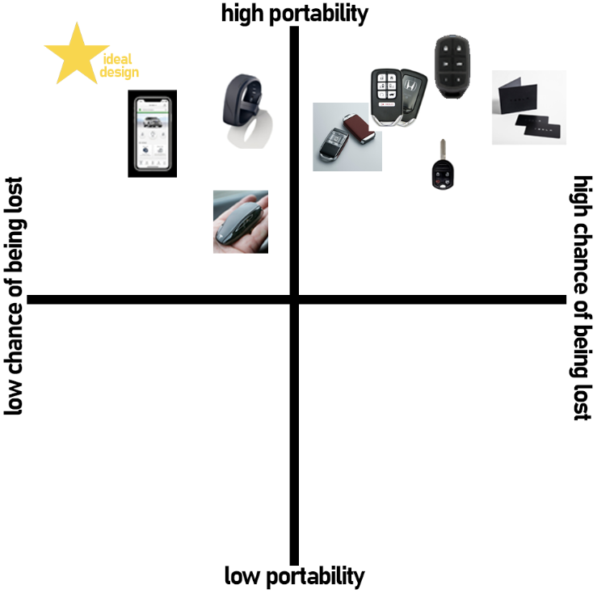

Figure 26: design space of portability vs. chance of losing

**Aesthetic vs. ease to figure out**

Mechanical key: We assigned an Aesthetic value of 1 due to habituation to a mechanical key. The signifier of the mechanical key is most likely to invoke a neutral or negative response. Also, due to the habituation of use we rated the ease of figuring out operation of the artifact would be a easiest rating of 2

Remote key: The remote key is the current majority key used among the population group. We determined that most users would rate their current or most recognized mental model as a neutral answer. In that basis we used 3 for both our Aesthetic scale and ease of access in a 1-5 rating scale

Nontraditional key: In our assessment of Nontraditional keys we determined that the user would have slightly above average feedback due to new novelty and nontraditional manner of interaction. This is also the justification for the raised level of ease of figuring out.  
Ideal design: Our justification for Aesthetics to be set at the highest level is due to the ideal redesign. The feedback’s target is at maximum aesthetic value as a goal. Same with ease of figuring out is set at the easiest level of accessibility for the user.

Redesign: The aesthetic of the redesigned key is based on the remote key, so it has the same aesthetic score. It is easy to figure out with the symbols and large buttons to bridge the **gulfs of execution and evaluation**.

|  | Aesthetic (1 ugly - 5 aesthetic) | Ease of figuring out (1 easy - 5 difficult) |
| --- | --- | --- |
| Mechanical key | 1 | 2 |
| Remote key | 3 | 3 |
| Nontraditional key (e.g., app, watch) | 4 | 4 |
| Ideal design | 5 | 1 |
| Redesign | 3 | 1 |

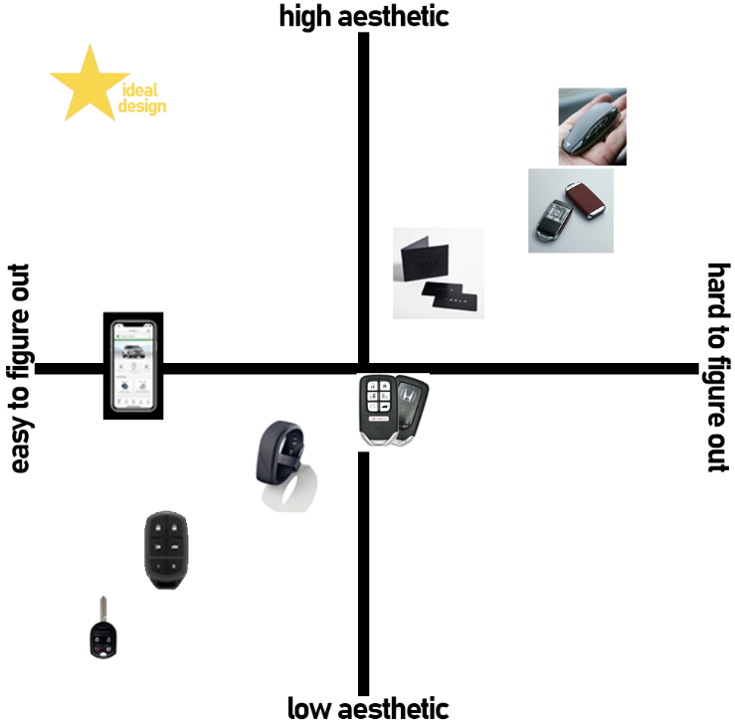

Figure 27: design space of aesthetic vs. ease of figuring out

**Part B: Redesign**

For our redesign, we are going to be using a remote key fob as 6 out of 10 participants that have multiple cars prefer a remote key. The redesigned key will be simple and have only four buttons: lock, unlock, trunk, panic. Of the respondents, there was only one that included a different button which allowed for the car’s lights to be turned on. To avoid **capture or description-similarity slips** between locking and unlocking the button will have different textures on the key fob. Each button will be big enough that it will be less likely to accidentally press the wrong button, which one of the interviewees mentioned as the part of their car key they liked, saying, “The buttons are really easy to press and are big enough to easily press without accidentally pressing a different button.” There will also be clear designs on the key to **signify** which each button does. As shown in figure 28, the key will also be a small shape as 13 out of 27 keep their keys in their pockets or purses. To accompany the other 14 people that use a lanyard there will be a small hook on the end of the key. To avoid **memory-lapse mistakes** of forgetting where the keys are located there will be a chip inside the key that tracks location. There can then be an app that tracks the key fob similar to Find My iPhone. The key will also automatically lock the car if it senses it is going out of range. This will help avoid any **memory-lapse slips** of leaving the car unlocked.

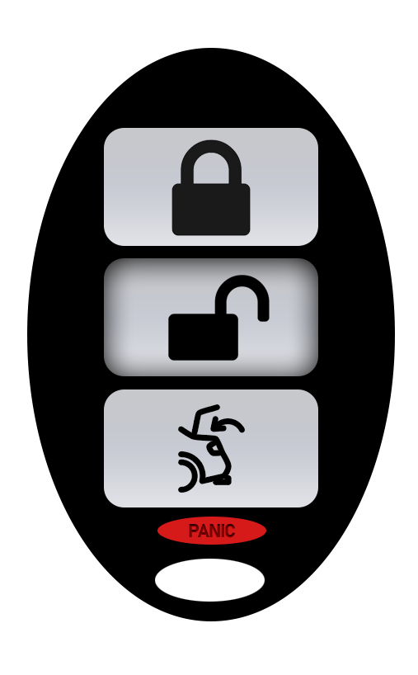

Figure 28: prototype of our redesigned key

There are definitely some **tradeoffs** in this redesigned key. We chose a remote style car key, which is more likely to be lost than some other designs. However, it is optimized to make it easy to carry around without losing. It also isn’t the most aesthetic design, which is subjective but has better functionality and less possibility of error with the buttons.

**Extra Credit:**

<https://drive.google.com/file/d/1RfBRZtmFbjJm9D7CygQx-CHR_pytkRku/view?usp=sharing>